|  |  |  |  |
| --- | --- | --- | --- |
| *Assignment 1* | *Name:- Muhammad Zaid* | *SID: - 12248* | *ClD:-*  *107987* |

Question 1:-

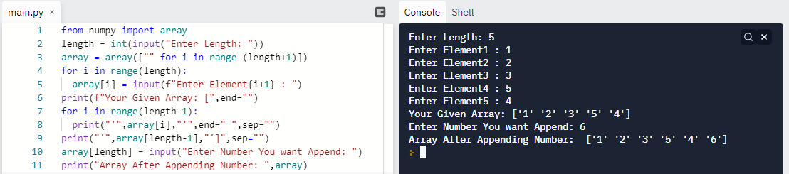

Question 2:-

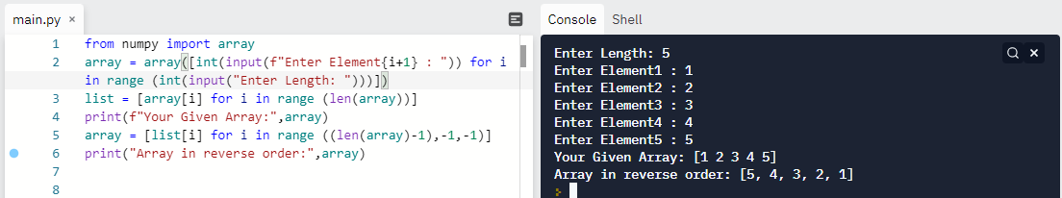

Question 3:-

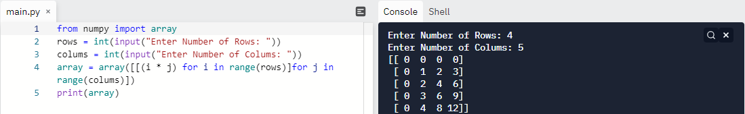

Question 4:-

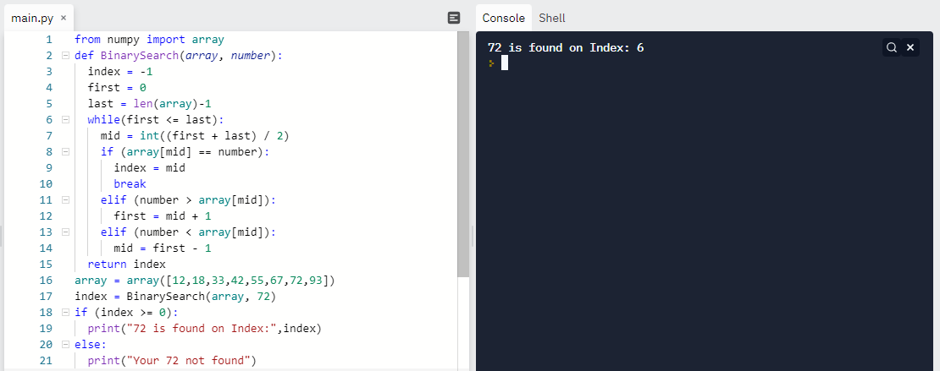

Question 5:-

